**Document Header**

TokiBattle

Requirements and Specification Document

11/04/2019, version 1, version 2

**Project Abstract**

TokiBattle is an online web application allowing two users to battle with Tokimon online. Each competitor has a team of Tokimon with unique moves and abilities. The objective of a Tokimon battle is to knock out each Tokimon on the opponent’s team. In each simultaneously executed turn, players can use their currently active Tokimon to attack the opponent or switch their active Tokimon to another Tokimon on their team. Tokimon moves do different amounts of damage based on the stats of the attacker and defender. Users can create an account and log in, then challenge another user to a battle or accept a challenge. TokiBattle will include sprites for each Tokimon, as well as animations for the moves. Information about each individual Tokimon’s stats and moves, as well as information about the moves themselves, will be stored in a database. TokiBattle will allow players to experience an alternative to Pokémon battles, with a different set of creatures and different type rules (in Pokémon, each creature has one or two types, whereas Tokimon have an integer value between 0 and 100 for every type). This fresh take on the popular game format will appeal to Pokémon fans who want to experience a different metagame.

**Customer**

TokiBattle has two types of customers. The first type is the hardcore Pokémon fan who enjoys battling with other trainers on their Nintendo device or on online services such as Pokémon Showdown. This customer already clearly enjoys creature-battling games with simultaneously executed turns, and will likely be curious to see which strategies will succeed with TokiBattle’s unique stat system. This customer needs an interesting and strategic battling system.

Our second kind of customer is a more casual player, who likely grew up playing Pokémon but has not played any of the newer games in years. This kind of customer exists in droves, and often feels a great sense of nostalgia for the original 151 Pokémon but dislikes the design of the newer creatures. The key for attracting this kind of customer will be to create simple yet loveable sprites for our Tokimon. Unlike our other customer, this one does not care very much about the game’s mechanical intricacies, and is unlikely to notice the difference between TokiBattle and Pokémon’s stat and type systems. The game’s “juice” (sprites, animations, sounds) will be more important for winning this customer over.

**Competitive Analysis**

TokiBattle’s biggest competitor is also its greatest benefactor. We obviously do not expect TokiBattle to overtake Pokémon as the number one creature battling video game. In fact, the majority of Pokémon’s playerbase is unlikely to see a reason to play Tokimon over its big brother. But we are not trying to target that whole playerbase – just the two kinds of customers listed above. Because of this, TokiBattle actually relies on the association with Pokémon so that customers will immediately know what kind of game it is, and then can discover the differences between the two games.

As noted in the “Customers” section, TokiBattle will benefit from its unique type and stat system. This sets the game apart from Pokémon and will inspire a certain kind of player to try the game. TokiBattle also is in the position to capture nostalgic fans who are jaded by the design choices and complexity of the newer Pokémon games.

TokiBattle’s similarities to Pokémon will be its “foot-in-the-door,” while the differences between the two games will keep our users wanting to keep coming back for more.

**User Stories**

**Actors:**

* Regular user (person who battles Tokimon on the site)
* Administrator (person who can battle Tokimon and see information from other users)

**Login - 3 points – Iteration 1**

**Story:** As a regular user, I want to create my account and log in with my username and password so that I soon will be able to choose some Tokimon and start battling!

**Triggers/Preconditions:** I am interested in playing TokiBattle, but I know that I need an account to do so. Currently there is no option to log into TokiBattle, so no one can make teams or battle.

**Actions/Postconditions:** The TokiBattle development team will add a login functionality using a database of usernames and passwords. Usernames must be unique as they are the database’s primary key. Once this feature has functionality, users will be able to create an account and log in, and soon they will be able to create teams of Tokimon that are associated with their unique username.

**Acceptance Tests:**

* Users can create an account and access the landing page.
* Returning users can re-log into their account with the username and password they chose.
* Passwords should be hidden from view while they are being typed.
* An invalid username with an invalid password should return a failure message.
* An invalid username with a valid password should return a failure message.
* A valid username with an invalid password should return a failure message.
* A blank username with a valid password should return an error message.
* A valid username with a blank password should return an error message.
* A blank username with a blank password should return an error message.
* The “Enter the Hall of Fame” link on the victory page links to TokiBattle’s Twitter page.
* The “Enter the Hall of Fame” link on the loss page links to TokiBattle’s Twitter page.

**Administrator Login - 3 points – Iteration 1**

**Story**: As an administrator, I want to be able to see all of the users and (when the feature is available) their teams of Tokimon so that I can better balance each Tokimon’s stats and moveset.

**Triggers/Preconditions:** Without administrator permission, it is not easy for anyone to see information such as users and teams, because that data is stored in databases, which are less accessible and user-friendly than displays on a web page. Currently, there is no administrator login.

**Actions/Postconditions:** The TokiBattle development team will hard-code several usernames as administrators in the database of users. The development team will then create a button with a link to a page that shows all TokiBattle usernames. This page will only be available to administrators. The data on this page is pulled from the database of users.

**Acceptance Tests:**

* Administrator can create an account and access the landing page.
* Returning administrators can re-log into their account with the username and password they chose.
* Passwords should be hidden from view while they are being typed.
* An invalid username with an invalid password should return a failure message.
* An invalid username with a valid password should return a failure message.
* A valid username with an invalid password should return a failure message.
* A blank username with a valid password should return an error message.
* A valid username with a blank password should return an error message.
* A blank username with a blank password should return an error message.
* Administrators can access the page with the table of users.
* When new users are added, administrators can see the updated table.
* When regular users try to access the administrator-only page, they see a page that says “This page only available for administrators”.

**Tweeting Results - 3 points – Iteration 2**

**Story:** As a trainer who just finished a battle, I want TokiBattle to Tweet the battle’s results to the world so that my friends can congratulate me for my win or console me for my loss.

**Triggers/Preconditions:** I just finished a battle, but no one knows how it went except me and my opponent. What if my opponent lies and says they won the battle when really I won? It would be nice to have some proof.

**Actions/Postconditions:** The TokiBattle development team will use Twitter’s API to automatically Tweet out battle results. Winning and losing trainers will be directed to a victory/loss page after the battle. This page will display a custom victory/loss message. The two players’ usernames will then be passed into a Tweet function that Tweets out the results of the battle on TokiBattle’s Twitter page.

**Acceptance Tests:**

* The victory page accurately displays the winning trainer’s username.
* The loss page accurately displays the losing trainer’s username.
* The victory page triggers an automatic Tweet from TokiBattle’s Twitter account.
* The loss page triggers an automatic Tweet from TokiBattle’s Twitter account.
* The victory Tweet accurately displays the winning trainer’s username.
* The loss Tweet accurately displays the losing trainer’s username.
* If a trainer is not logged in, the victory page should redirect the trainer to the login page.
* If a trainer is not logged in, the loss page should redirect the trainer to the login page.
* The “simulate a victory” button should direct a user to the victory page.
* The “simulate a loss” button should direct a user to the loss page.

**Teambuilder - 4 points – Iteration 2**

**Story:** As a user who enjoys teambuilding, I want to be able to create and save a team of Tokimon so that I know which Tokimon I will be able to battle with.

**Trigger/Preconditions:** Tokimon is a deeply strategic game, so I want to be able to build many teams to try out different strategies against my opponents. Currently there is no teambuilding tool, so I am unable to build a team with which to battle.

**Actions/Postconditions:** The TokiBattle development team will create a database of Tokimon and a database of teams so that trainers can view all the Tokimon and add various Tokimon to their various teams. Trainers will then be able to see each team they have created. Trainers will later be able to use these teams in battle.

**Acceptance Tests:**

* When the “Create Team” button is clicked and a unique team name is submitted, the user is directed to a page where they can view all available Tokimon and add them to the selected team.
* Once a Tokimon is added to a team, the option to add it to the team again disappears (there are no duplicates allowed on a Tokimon team).
* When a trainer tries to create a new team with a name that has already been used, TokiBattle will stop this new team from being created.
* When the user logs in, they see a unique landing page with their teams and the option to create more teams.
* When the user logs in and is directed to the landing page, the URL will include their username.
* If the user then logs in with a different username, they should no longer be able to see the teams they created under their other username.
* If the user logs back in with the username they used to create their teams, they should be able to see the teams they created under that username before.

**Battle Scene – 2 points – Iteration 2**

**Story:** As a trainer starting a battle, I want to see an intro animation to get me pumped up for the battle and then see the battlefield.

**Trigger/Preconditions:** Without getting hyped up, I’m not going to enjoy a battle. Right now there is nothing to get me hyped up. “Juice” is the most important part of game design, so keeping me as a user engaged is very important.

**Actions/Postconditions:** The TokiBattle development team will create a fun and exciting battle countdown page. This page will appear before a battle, and will lead into the battle screen.

**Acceptance Tests:**

* The battle scene page should appear when the test link is clicked.
* The battle scene page should count down and then redirect to the battle screen.

**Logout - 2 points – Iteration 2**

**Story:** As a regular user, I want to be able to exit the program and be sure that I have totally logged out of the website.

Triggers/Preconditions: Without a proper logout function, I cannot be sure that I have properly exited the website. I need a quick and reliable way to ensure that I am logged out. Currently the only way to do this is to exit the browser.

Actions/Postconditions: The TokiBattle development team will add logout functionality by adding a log out button on the landing page of the website. The logout button will take the user from their current page and send them to the login page where the user started. The button will also adjust the cookies to indicate that the user is no longer logged in.

Acceptance Tests:

• User can find the logout button on the landing page.

• User can click the logout button.

• The button sends the user to the login page.

• The button adjusts the cookies so that the user is no longer logged in.

• The user can log in again after logging out.

• The user can log in as a different user after logging out.

• The user can register as a new user after logging out.

• The user cannot access pages that require logging in after they log out.

**Battle Ready Page - 3 points – Iteration 2**

Story: As a regular user, I want the ability to see my team before I enter battle against my opponent. I want the ability to select my starting Tokimon and to see how they look on the battle stage.

Triggers/Preconditions: Currently there is no ability to view Tokimon on the battle stage and there is also no way to select the starting Tokimon before battle. The lack of a method to inspect my team based on how they look is a serious hindrance to my enjoyment as a user.

Actions/Postconditions: The TokiBattle development team will add a visually appealing way for users to access and inspect their various team members. Specifically the team will create battle page 1 which will show the user a countdown to the start of the battle. Then the dev team will create page 2 which will show just the users Tokimon on the battle screen. They will be able to view each Tokimon by selecting them.

Acceptance Tests:

• Users can view the battle loading page which contains a countdown video.

• Users are able to see the video displayed with add blockers active.

• Users are redirected to the battle 2 once the countdown ends.

• Users can see the battle stage and six Tokimon in a team.

• Users can select from the six Tokimon and view them on the stage.

• Tokimon on the stage move.

• Selecting a different Tokimon changes the Tokimon on the stage.

• Each Tokimon can be seen on stage.

**Future Stories:**

* **Banhammer – 1 point – Iteration 2:** As an administrator, I want to be able to remove users from the user database so that I can ban toxic players and “lay off” inactive users.
* **View Move Data – 3 points – Iteration 2:** As a user who is particularly interested in the mechanics of the game, I want to be able to view the base power, accuracy, and type of each move.
* **Online Trainers – 3 points – Iteration 2:** As a user wanting to battle another user, I want to be able to see which users are online.
* **Trainer Wants to Fight!** **– 2 points – Iteration 2:** As a user wanting to battle another user, I want to send a challenge to another user who is online.
* **Accept Challenge?** **– 3 points – Iteration 2:**  As a trainer who has received a challenge, I want to have the option accept it, which triggers the battle beginning, or decline it, and return to my business.
* **I Choose You! – 4 points – Iteration 3:** As a trainer who has just started a battle, I want to be able to choose a Tokimon from my team to start the battle with, and then once my opponent has done the same, I want to see both Tokimon on the screen.
* **Make a Move – 3 points – Iteration 3:** As a trainer in a battle, I want to be able to select a move on my currently active Tokimon, and once the opponent has done the same, I want each Tokimon to lose the right amount of health.
* **Return! – 3 points – Iteration 3:** As a trainer in a battle, I want to be able to select a Tokimon to switch to instead of using a move. Once the opponent has selected their move, I want my currently active Tokimon to switch.
* **Unable to Battle – 3 points – Iteration 3:** As a trainer who has just knocked out my opponent’s Tokimon by bringing its HP to 0, I want the opponent’s Tokimon to be unable to battle, and the opponent to have to select a new Tokimon and be unable to switch to the knocked out Tokimon.
* **Animations – 4 points – Iteration 3:** As a trainer in a battle, I want to see animations when Tokimon use moves.
* **We Have a Winner! – 2 Points – Iteration 3:** As a trainer who knocked out all of my opponent’s Tokimon, I want to see the victory page saying that I won the battle. Alternatively, if I lose a battle, I want to see the loss page saying that I lost the battle.

**Velocity**

The team is moving along with a reasonable velocity in iteration 2. We gained 14 velocity points in these two weeks between the five of us. This is over double the velocity points we gained in iteration 1 (6). We will have to ramp up our efforts in iteration 3, because there are 30 story points remaining, but some of these stories already have some progress on them behind the scenes. Additionally, with the high acceleration our team experienced going from iteration 1 to iteration 2, we are optimistic about our ability to tackle the higher-valued tasks in iteration 3.

**User Interface Requirements**

Teambuilder page concept. Similar to Pokémon Showdown. Users can select one of their existing teams or create a new one.

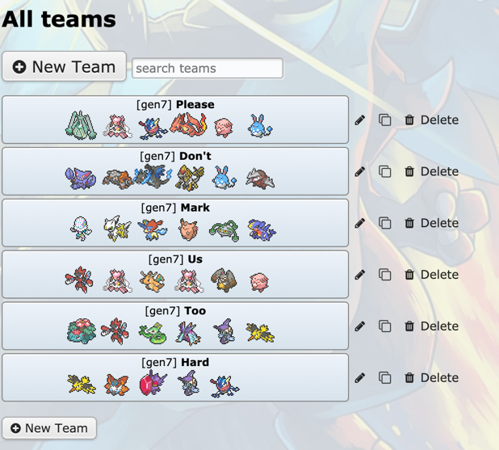

After selecting or creating a team, users will be directed to a page where they can add and remove Tokimon from their team. The sprites used in the Pic category are just Pokémon sprites in this mockup, but we’ll have our own original sprites. Names, stat numbers and moves are not final.

Your Tokimon on TestTeam

|  |  |  |  |  |  |  |  |  |  |  |  |  |  |  |  |  |
| --- | --- | --- | --- | --- | --- | --- | --- | --- | --- | --- | --- | --- | --- | --- | --- | --- |
| **Name** | **Pic** | **Fire** | **Water** | **Elec** | **Fly** | **Fight** | **Ice** | **HP** | **Att** | **Def** | **Speed** | **Move**  **1** | **Move**  **2** | **Move**  **3** | **Move**  **4** | **Del**  **from**  **team** |
| Erichu | Emolga icon | 23 | 48 | 88 | 50 | 65 | 76 | 55 | 70 | 30 | 85 | Soar | Zap | Freeze | Wave | Del |
| Steamo | Grimer icon | 79 | 71 | 55 | 39 | 30 | 51 | 80 | 33 | 90 | 37 | Heat | Burn | Freeze | Wave | Del |
| Enorgy | Golem icon | 78 | 67 | 78 | 12 | 19 | 68 | 45 | 91 | 31 | 88 | Taste | Zap | Freeze | Burn | Del |

Available Tokimon

|  |  |  |  |  |  |  |  |  |  |  |  |  |  |  |  |  |
| --- | --- | --- | --- | --- | --- | --- | --- | --- | --- | --- | --- | --- | --- | --- | --- | --- |
| **Name** | **Pic** | **Fire** | **Water** | **Elec** | **Fly** | **Fight** | **Ice** | **HP** | **Att** | **Def** | **Speed** | **Move**  **1** | **Move**  **2** | **Move**  **3** | **Move**  **4** | **Add**  **to**  **team** |
| Liono | Zubat icon | 80 | 12 | 33 | 20 | 55 | 34 | 80 | 70 | 30 | 71 | Heat | Zap | Freeze | Wave | Add |
| Seabie | Shellder icon | 10 | 71 | 30 | 90 | 31 | 55 | 80 | 42 | 80 | 60 | Soar | Kick | Freeze | Wave | Add |
| Chana | Ponyta icon | 85 | 44 | 78 | 34 | 5 | 10 | 66 | 90 | 31 | 22 | Code | Zap | Teach | Burn | Add |
| Nodie | Electrode icon | 32 | 44 | 81 | 68 | 12 | 41 | 36 | 36 | 36 | 89 | Soar | Zap | Freeze | Burn | Add |
| Thom | Ninetales icon | 100 | 52 | 60 | 20 | 17 | 46 | 1 | 100 | 1 | 100 | Soar | Zap | Code | Burn | Add |
| Leady | Togetic icon | 78 | 66 | 32 | 11 | 16 | 17 | 88 | 66 | 78 | 55 | Heat | Kick | Freeze | Wave | Add |
| Penny | Skarmory icon | 89 | 34 | 22 | 76 | 11 | 55 | 45 | 45 | 33 | 91 | Roll | Spin | Kick | Jump | Add |
| Maptu | Azumarill icon | 55 | 89 | 45 | 33 | 55 | 56 | 56 | 55 | 85 | 71 | Soar | Spin | Freeze | Wave | Add |
| Skyte | Noctowl icon | 88 | 10 | 77 | 77 | 10 | 12 | 78 | 66 | 45 | 78 | Taste | Kick | Kick | Burn | Add |

Battle screen concept. Each player only sees their own screen, where they can choose to either use a move or switch Tokimon. Similar to Pokémon games.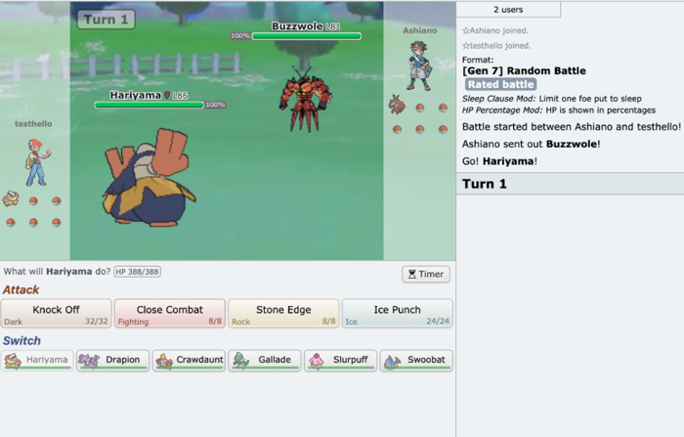

Victory screen that winning trainers are sent to after a battle

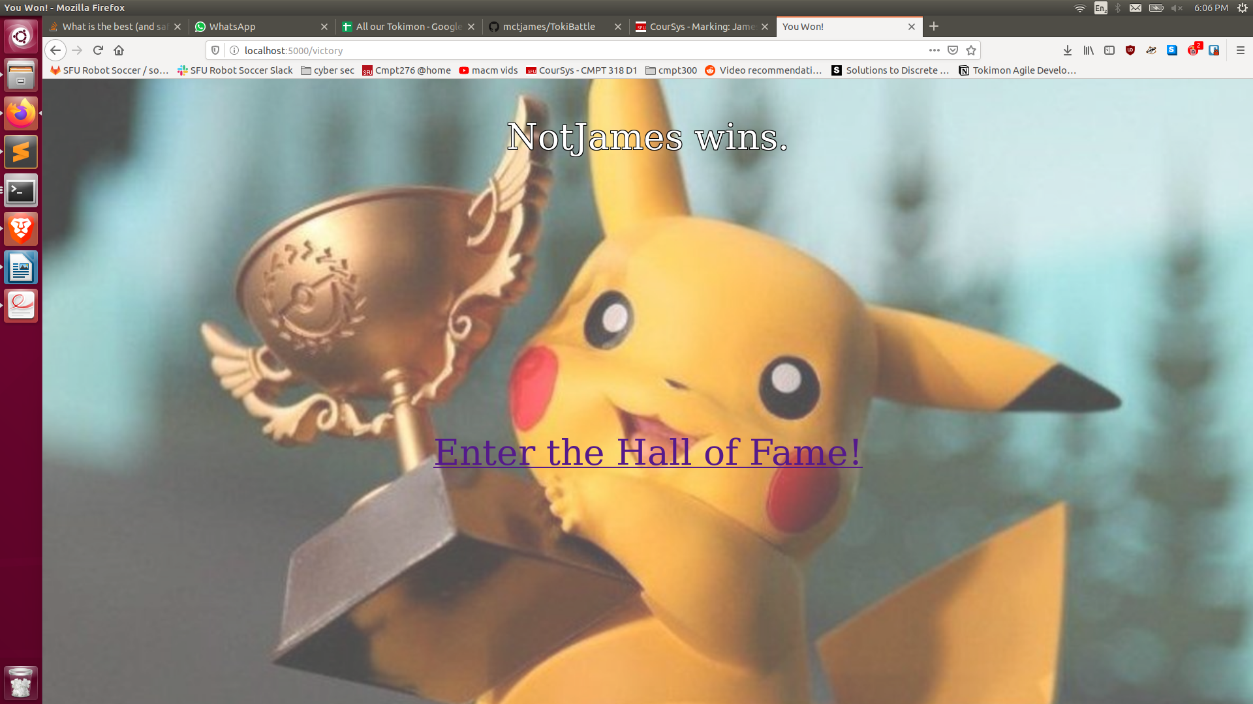

Loss screen that losing trainers are sent to after a battle

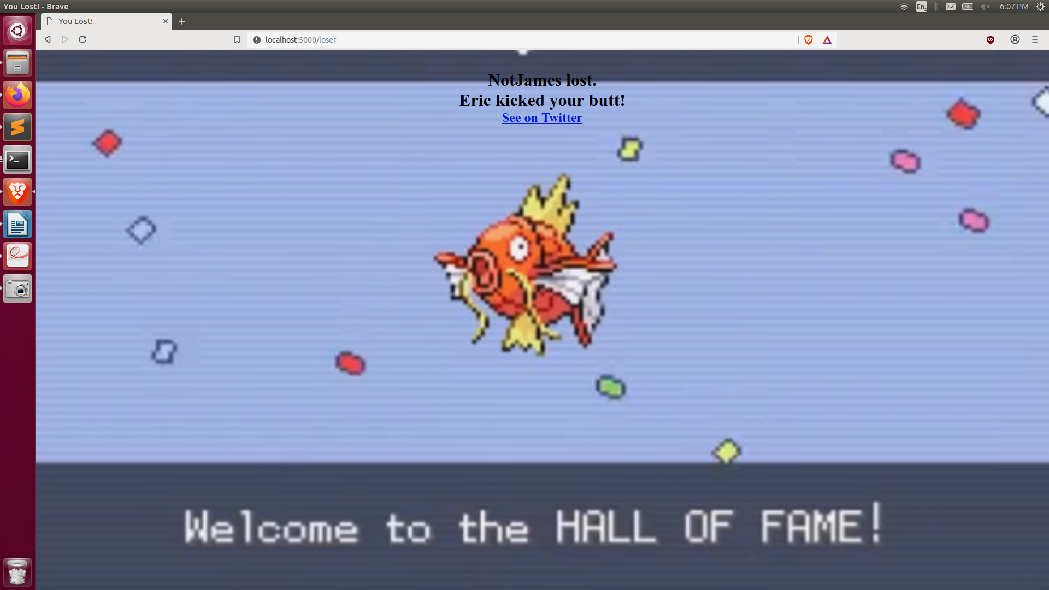

TokiBattle’s Twitter account that automatically Tweets out battle results. Profile picture and further customization to come later. Twitter link: <https://twitter.com/TokiBattle>

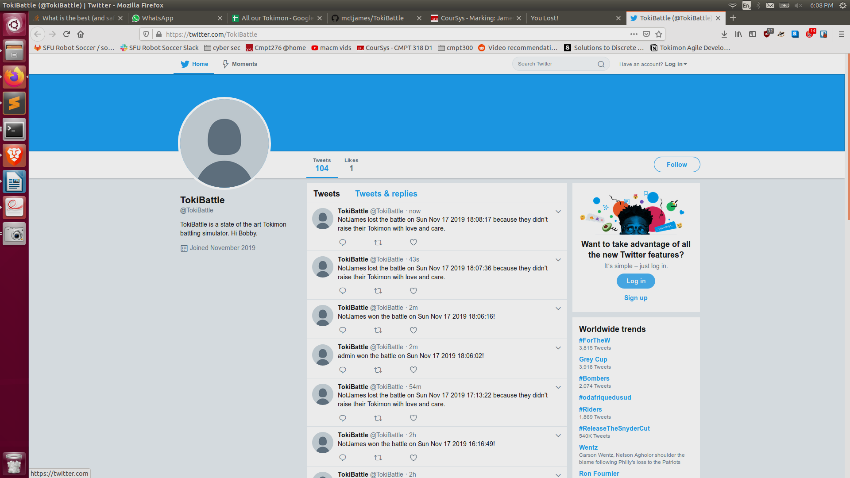

The countdown page that appears before a battle

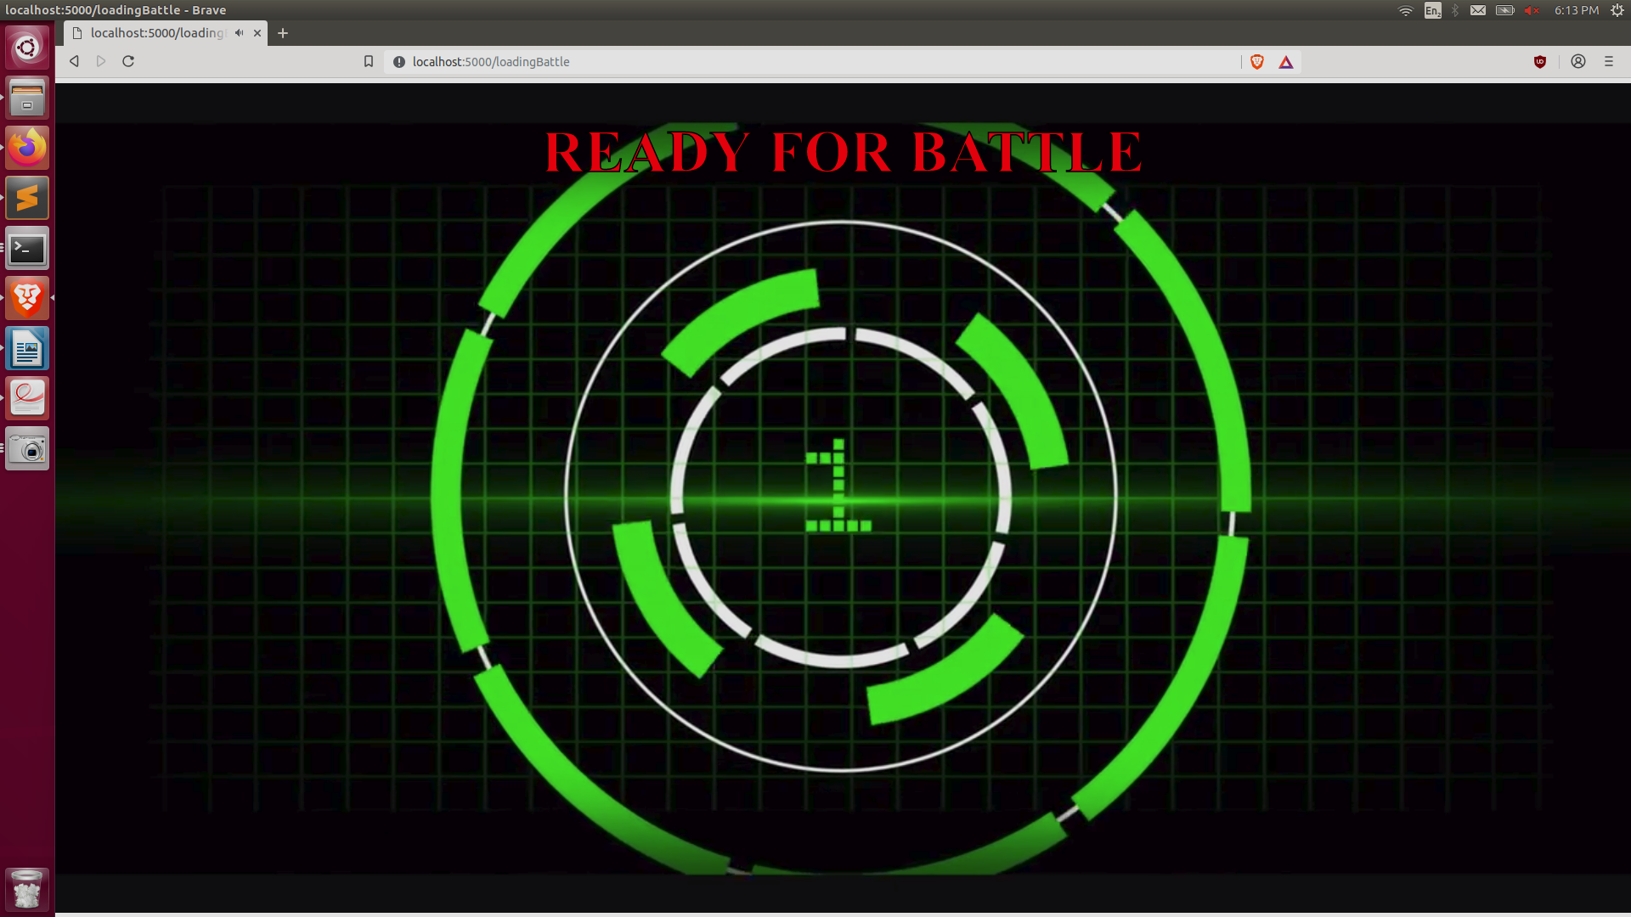

The battle screen where the user can select a Tokimon to fight

